Assignment 1
5110309783 陈宇翔

P1
Sleeping Barber Problem

This problem can be regarded as a simplified producer-consumer problem. To make the whole system easier, I just use one producer thread and one consumer thread, making them running in parallel.
Since I’ve ever written the code of this problem in pthread, I just modified that code to make it suitable with OpenMP. The code can be seen in the attachment.
In the producer thread, I use random numbers as the name of the customers. Meanwhile, I also use random integers as the arriving time of these customers, ranging from 0 to 4. And this arriving time can be modified in the definition of MAX_PROCESS_SLEEP, which is in the front of the code.
As for the consumer thread, I make the haircut time to be 5 second. This can also be modified by defining the time of haircut as a random number. (But I think the time for each cusotmer should be the same, so I just make it a fixed number.
The size of the waiting room is 5, which can be changed in BUFFER_SIZE.
The whole system will work for 20s, which can be modified by changing the definition of MAX_WORKING_TIME.
The screen shot of the running result is as follows:
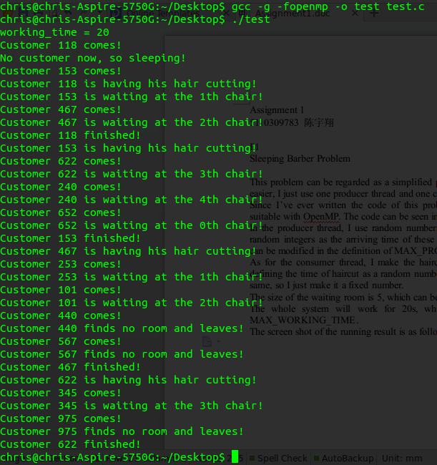
P2
Median Filter
In this problem, we need to get the median of the data in the window that we are processing to get rid of the noise. So to make the filter more practical, I need to read a file (of the pixel value of a certain image as a matrix) in the beginning of the code as the input. This can be processed by python or OpenCV, and since it’s not very related with the filter itself, so I just omitted the program to get pixel value in this report.
After get the data, to make it run in parallel, I divide the data in to multiple parts so that each thread can process almost the same number of data. For the part of data that can not be fully divided, you can see how I divide them in the code.
For each thread, I use a 5*5 window to process the median, and we can change the size of the window by modifying WINDOW_SIZE. In the beginning, I try to sort the data in the window using the bubble method. But with that method, we may do a lot of work that is not necessary, and that method can not run in parallel as a result of data dependency. So after discussing with my classmates, I find that we can get the median by counting how many points are that of a certain value. By adding the number of value, we can find the median easily.
In this program, I define the maximum value of a pixel to be 256, and the size of the image is 256*256, these parameters can all be changed in the definition part. In the end, the program will output the outcome value processed by median filter.
Codes are attached in the attachment.
Thank you.

